**Supply Chain Data Analysis Project Documentation**

Table of Contents

**Supply Chain Data Analysis Project Documentation** 1

**1. Project Overview** 2

2. Business Understanding 3

3. Data Understanding 3

4. Data Preparation 3

5. Exploratory Data Analysis (EDA) 3

6. Analysis & Modeling 4

7. Insights & Recommendations 4

**1. Project Overview**

* **Project Title**: Supply Chain Data Analysis
* **Date**: May 2025
* **Prepared By**: Group-2 DEPI
* **Team Members**:

1. Group Leader: Nada Kamal Mohamed
2. Group Member: ……
3. Group Member: ……
4. Group Member: ……
5. Group Member: ……
6. Group Member: ……

* **Objective**:

**This project aims to:**

**1. Demand Forecasting & Sales Insights**

* **Goal:** Understand product demand trends to guide inventory and production.
* **Analysis:**
  + Top-selling SKUs and product types (Number of products sold)

**2. Inventory Optimization**

* **Goal:** Ensure the right stock at the right time without overstocking.
* **Analysis:**
  + Compare Stock levels vs. the Number of products sold

### **3. Supplier & Manufacturing Efficiency**

* **Goal:** Improve production speed and cost-effectiveness.
* **Analysis:**
  + Compare Supplier name and Lead time
  + Analyze Manufacturing costs and Manufacturing lead time per product
  + Assess production performance vs. Production volumes

### **4. Quality Control**

* **Goal:** Reduce defects and improve product reliability.
* **Analysis:**
  + Average and distribution of Defect rates
  + Correlation between Inspection results and Defect rates
  + Link poor quality to specific suppliers or transportation modes

**5. Logistics & Cost Efficiency**

* **Goal:** Minimize shipping costs and delays.
* **Analysis:**
  + Compare Shipping times, Shipping costs, and Transportation modes
  + Analyze total Costs vs. product revenue
  + Evaluate route efficiency and carrier performance

## ****2. Business Understanding****

* **Problem Statement**:

The company seeks to improve the efficiency, reliability, and profitability of its skincare supply chain. Challenges include inconsistent inventory levels, variable supplier lead times, high shipping costs, quality control issues, and a lack of visibility into sales performance across SKUs and customer segments.

* **Business Goals**:

1. Optimize Inventory Management by aligning stock levels with sales demand to reduce overstock and avoid stockouts.
2. 2. Improve Demand Forecasting by analyzing sales trends and customer demographics to anticipate future demand accurately.
3. 3. Enhance Supplier and Manufacturing Efficiencyby reducing lead times and manufacturing costs while maintaining quality.
4. 4. Minimize Logistics and Shipping Costs by analyzing carrier performance, shipping modes, and route efficiency.
5. 5. Improve Product Quality by monitoring defect rates and inspection results to identify and eliminate issues in production and delivery.

* **Key Stakeholders**:

1. Supply Chain Manager: Needs insights to manage stock, reduce waste, and improve delivery timelines.
2. Procurement Manager: Requires supplier performance data to make informed sourcing decisions.
3. Production Manager: Focused on optimizing production lead times and reducing manufacturing costs.
4. Quality Assurance: Interested in defect rates and inspection data to maintain product standards.
5. Logistics/Operations Manager Aims to reduce transportation time and cost while ensuring timely deliveries.
6. Sales and Marketing Team: uses sales performance and customer demographics for targeted campaigns and promotions.
7. Executive Leadership: needs overall performance metrics to support strategic decisions and profitability.

* **Success Criteria**:

1. Reduction in average stockouts and overstock situations.
2. Increase in forecast accuracy for high-demand SKUs.
3. Decrease in average lead times and manufacturing costs.
4. Reduction in shipping time and transportation costs.
5. Lower defect rates and fewer inspection failures.
6. Increased overall revenue and improved supply chain responsiveness.

## ****3. Data Understanding****

* **Data Sources**: <https://drive.google.com/file/d/1fpxB64Z4iuKAbXD4Jf2Dc0TQnw8ulZmR/view?usp=drive_link>
* **Type of Data**:

Structured Tabular Data: The dataset is in CSV format and contains numeric, categorical, and textual fields representing various aspects of the skincare supply chain.

* **Data Description**:
* The dataset includes **100 records** and **27 columns** related to:
* **Product Information:** Product type, SKU, Price, Availability
* **Sales & Customer Data:** Number of products sold, Revenue generated, Customer demographics
* **Inventory & Orders:** Stock levels, Order quantities
* **Shipping & Logistics:** Shipping times, Shipping carriers, Shipping costs, Transportation modes, Routes, Costs
* **Supplier & Manufacturing:** Supplier name, Location, Lead time, Production volumes, Manufacturing costs, Manufacturing lead time
* Quality Control: Inspection results, Defect rates

## ****4. Data Preparation****

* **Data Cleaning and Data Transformation**:
* Total Columns Before: 27
* Total Columns After Cleaning: 24
* Rows Removed: 0 (no duplicates found)
* Special Notes: The Dataset is clean and ready for analysis. No imputation was necessary.

1. Price:

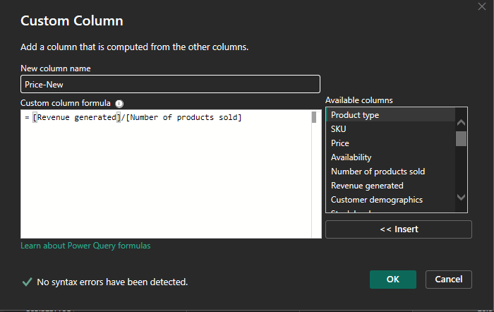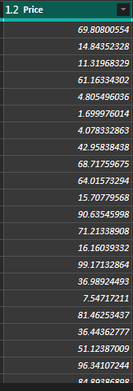

1. **Empty Column:**

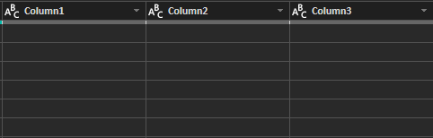

**Taken Action: Deleted**

1. **Action Taken on all fields in the dataset:**

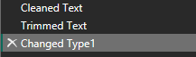

1. **Defect Rate:**

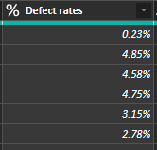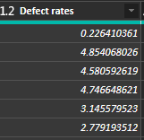

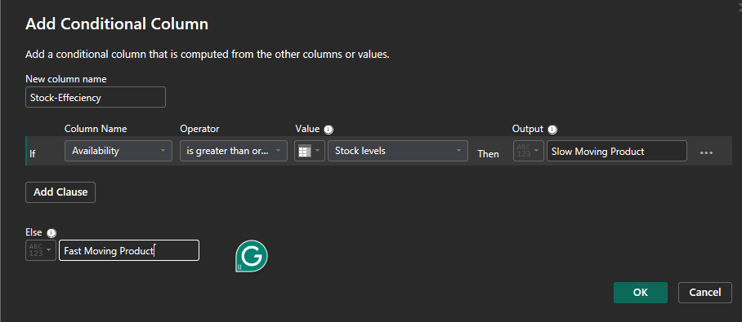

**Creating a Conditional Column to show Stock efficiency**

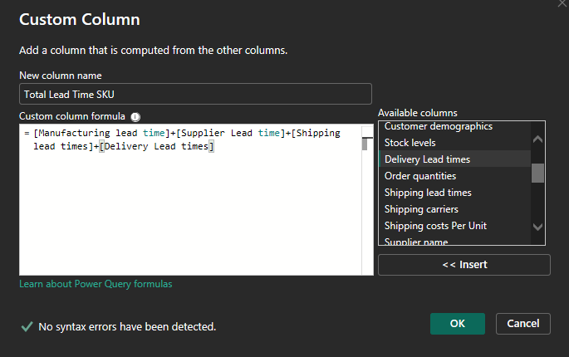

**Creating a Custom Column to show the Total Lead Time of each SKU**



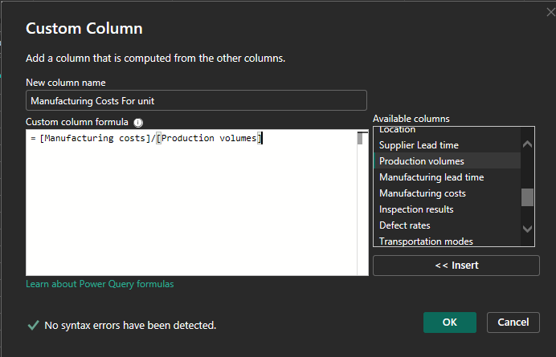

**Creating a Custom Column to show Manufacturing Costs for a unit**

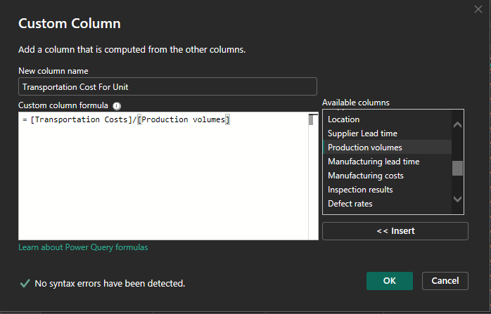

**Creating a Custom Column to show Transportation Costs for a unit**



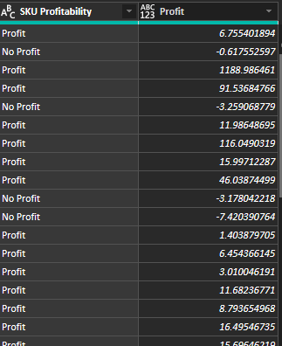

**Creating a Custom columns to show Profitability for SKUs**



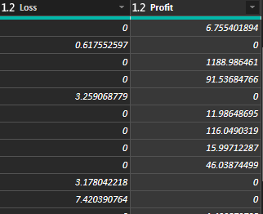

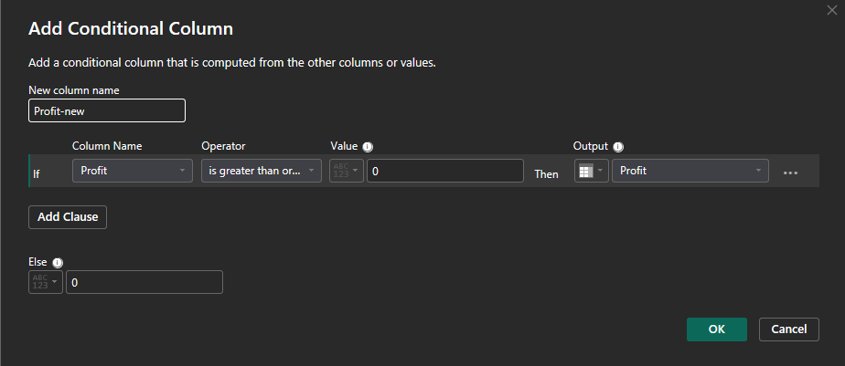

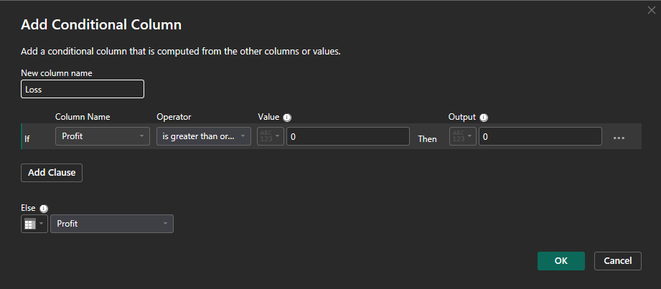

**Creating Custom columns to show Profitability and loss for SKUs**

* 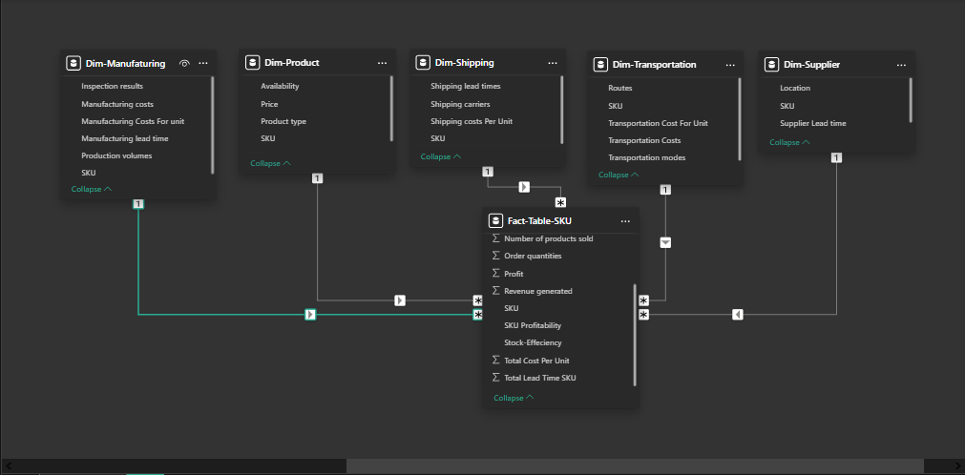**Data Modeling**:

## ****5. Exploratory Data Analysis (EDA)****

* **Summary Statistics**:
* **Visualizations**:
* **Key Findings**:

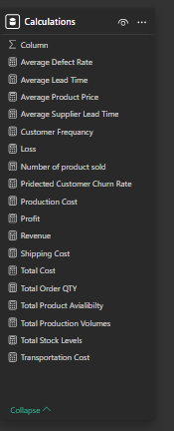

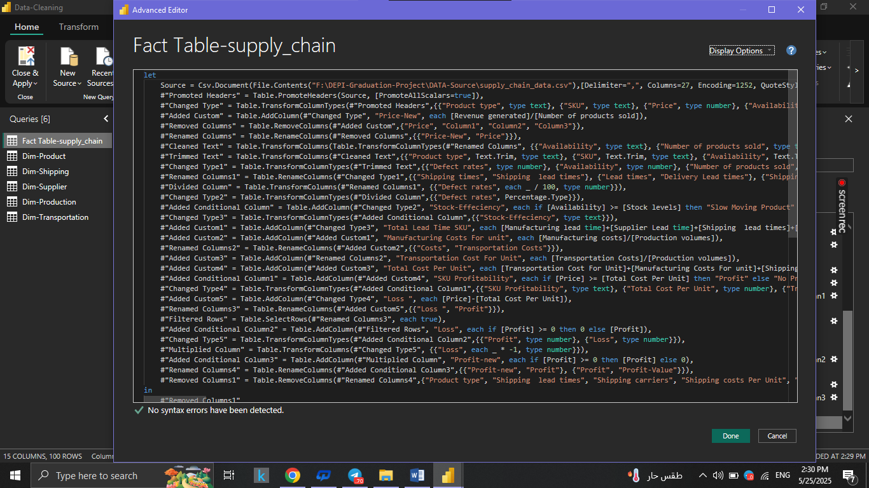

## ****6. Analysis & Modeling****

* **Analytical Techniques Used**:
* **Tools & Software**:
* **Assumptions Made**:
* **Model Outputs**:

## ****Insights & Recommendations:****

## SKU Analysis:

## 

* **Insights Gained**:

1. Top SKUs: SKU10, SKU4, SKU9 lead sales (95.0%, 94.7%, 90.0%); SKU0, SKU33, SKU19 dominate orders (95.0%, 94.0%, 85.0%).
2. Profit Issue: Revenue 577.60K, but profit only 3.44K with 87.85 loss; SKU0 high revenue (1,119), others lag (e.g., SKU22: 335).
3. Stock Gaps: SKU12, SKU51 at 100% stock/availability; SKU0, SKU4 lower availability (87%, 97%) despite high stock.
4. Lead Time Delays: SKU30 (90 days), SKU0 (82 days) have longest lead times; SKU49, SKU84 better (85, 82 days).
5. Customer Satisfaction: 100%, but at risk from stock/lead time issues.

* **Recommendations**:

1. Boost Profit: Adjust pricing/costs for SKU0, SKU22, SKU55 to cut 87.85 loss.
2. Optimize Stock: Reallocate for SKU0, SKU4 to match high demand, avoid stockouts.
3. Cut Lead Times: Work with suppliers to reduce SKU30, and SKU0 lead times (90, 82 days).
4. Improve Forecasting: Use sales data for SKU10, SKU4, SKU0 to align stock with demand.
5. Leverage Satisfaction: Market top SKUs (SKU0, SKU10) to grow, but monitor stock/lead time risks.

## Customer Analysis:

* **Insights Gained**:

1. Customer Demographics: Unknown (31%), Female (35%), Non-binary (27.9%) lead frequency; Male (4.8%) highest churn risk.
2. Sales by Demographics: Unknown (46K), Female (15K) top sales; Male (8K) lowest despite high churn risk.
3. Order & Lead Time: Unknown (1,950 orders, 54 days lead), Female (1,421 orders, 51 days) dominate; Male (899 orders, 58 days) lags.
4. Delivery Performance: 15% on-time, average lead time 31.92 days, indicating delays.
5. Financials: Revenue 577.60K, profit 3.44K, order qty 4.9K; profitability remains low.

* **Recommendations**:
  1. Customer Demographics: Unknown (31%), Female (35%), Non-binary (27.9%) lead frequency; Male (4.8%) highest churn risk.
  2. Sales by Demographics: Unknown (46K), Female (15K) top sales; Male (8K) lowest despite high churn risk.
  3. Order & Lead Time: Unknown (1,950 orders, 54 days lead), Female (1,421 orders, 51 days) dominate; Male (899 orders, 58 days) lags.
  4. Delivery Performance: 15% on-time, average lead time 31.92 days, indicating delays.
  5. Financials: Revenue 577.60K, profit 3.44K, order qty 4.9K; profitability remains low.

## Production Analysis:

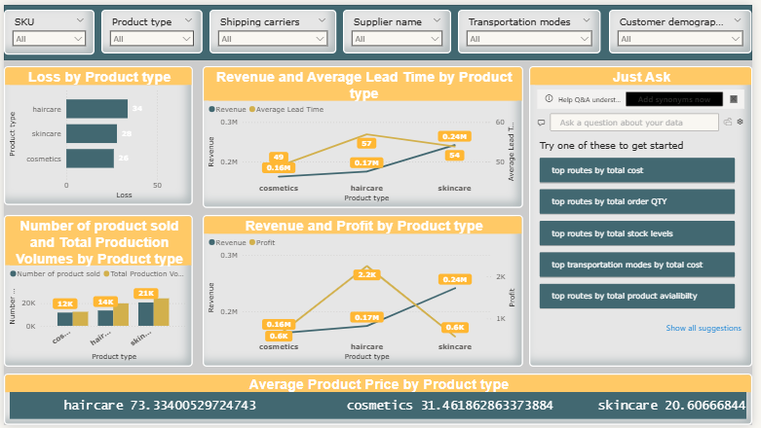

**Insights Gained**:

* Skincare: High manufacturing costs ($1.5K) vs. low price ($0.5K); Haircare: Low costs ($0.5K), high price ($1.5K).
* Haircare has more production (1.8K) and orders (2.4K) than skincare (1.3K, 1.5K).
* Haircare availability (1.5K) with lower costs ($500); Skincare availability (1K) with higher costs ($1.5K).
* Many SKUs pending inspection (40), fewer fail (20) or pass (10).

**Recommendations**:

* Raise skincare prices or cut costs.
* Increase haircare production to meet demand.
* Reduce skincare manufacturing costs.
* Speed up inspection process to clear Checkup.

## Shipping Analysis:

## 

**Insights Gained**:

1. Revenue varies by carrier and product: Carrier A’s haircare peaks at 67K, while Carrier C’s skincare is lowest at 175K.
2. Shipping lead times are longest for Carrier C’s skincare (228 days) and shortest for Carrier A’s cosmetics (172 days).
3. Stock levels are highest with Carrier B (2111), but availability is highest with Carrier A (1943).
4. Order quantities are highest with Carrier B (2K), followed by Carrier A (1.6K) and Carrier C (1.3K).

**Recommendations**:

1. Optimize Carrier C’s operations to reduce long lead times, especially for skincare.
2. Increase stock levels for Carrier A to match its high availability and demand.
3. Focus on Carrier B for higher order fulfillment due to its strong order quantity performance.
4. Investigate the 87.85K loss to improve overall profitability.

## Supplier Analysis:

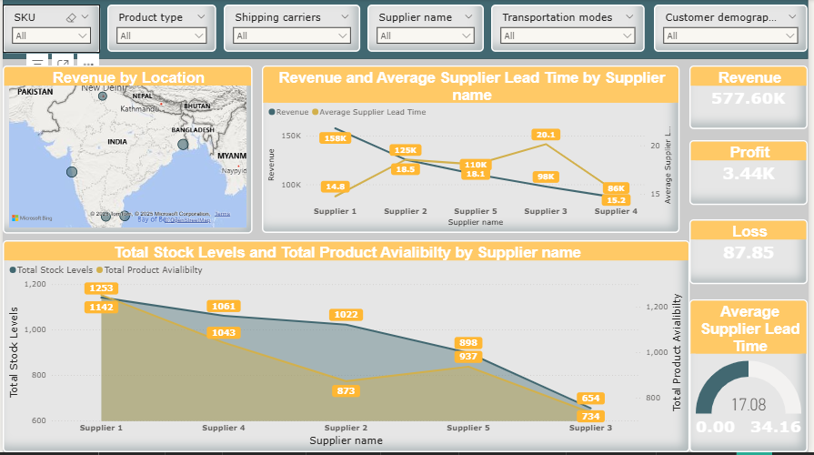

**Insights Gained**:

* Revenue by location shows varied performance, with some areas generating up to 158K.
* Supplier 1 has the highest stock levels (1233) and availability (1142), while Supplier 3 has the lowest (674, 734).
* Supplier 1 has the shortest lead time (14.8 days), while Supplier 3 has the longest (20.1 days).
* Profit is 3.44K, but a significant loss of 87.85 is noted.

**Recommendations**:

* Focus on high-revenue locations to boost overall sales.
* Address Supplier 3’s low stock and long lead times to improve supply chain efficiency.
* Investigate the cause of the 87.85K loss and implement cost-saving measures.
* Leverage Supplier 1’s strong performance for broader supply needs.

## Transportation Analysis:

## 

**Insights Gained**:

1. Transportation Modes by Routes: Route A has the most modes (around 50) and highest cost (around 40), while Route C has the fewest (around 20) and lowest cost (around 15).
2. Revenue by Modes: Rail leads with 97.58K (59%), followed by Sea (27.89K, 17%), Air (26%), and Road (16.54K, 10%).
3. Transportation Cost by Modes: Rail has the highest cost (around 40), Sea the lowest (around 15).
4. Average Lead Time: Rail has the longest lead time (56.57 days), Sea the shortest (47.53 days).
5. SKUs by Modes: Rail handles the most SKUs (around 30), Sea the fewest (around 10).

**Recommendations**:

* 1. Optimize Rail Efficiency: Reduce rail costs and lead times despite high revenue and SKU volume.
  2. Increase Sea Usage: Leverage sea transport for lower costs and faster lead times.
  3. Review Route A Costs: Investigate and reduce Route A’s high transportation costs.
  4. Balance SKU Distribution: Spread SKUs across modes to lessen reliance on rail and avoid delays.